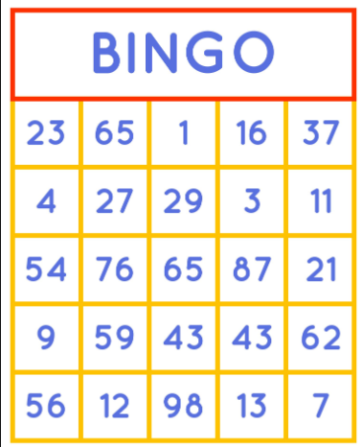
Bingo Numbers

Some bingo numbers have names. Here are some examples:

# Name How it’s spoken
2 One little duck “One little duck – number 2”
3 Cup of tea “Cup of tea – number 3”
4 Knock at the door “Knock at the door – number 4”
6 Half a dozen “Half a dozen – number 6”
7 Lucky for some “Lucky for some – number 7”
8 Garden gate “Garden gate – number 8”
11 Legs “Legs eleven”
12 One dozen “One dozen – number 12”
13 Unlucky for some “Unlucky for some – 13”
16 Sweet sixteen “Sweet sixteen”
17 Dancing queen “Dancing queen – 17”
21 Key of the door “Key of the door – 21”
22 Two little ducks “Two little ducks – 22”
50 It’s a bullseye “It’s a bullseye – 50”
66 Clickety click “Clickety click – 66”
70 Three score and ten “Three score and ten – 70”
88 Two fat ladies “Two fat ladies – 88”

For other numbers:

33 “All the threes – 33” 56 “5 and 6 – 56”
44 “All the fours – 44” 78 “7 and 8 – 78”
etc. etc.

According to Wikipedia, all the numbers from 1 to 90 have bingo names:
https://en.wikipedia.org/wiki/List_of_British_bingo_nicknames

